**Contents**

Group K Information: 2

Introduction: 2

Concept: 3

Background Research: 3

Method: 4

**Focus Groups and Interviews:** 4

**Case Studies and Academic Research:** 4

**Competitive analysis:** 4

**Expert Consultation:** 5

**Online Survey:** 5

Requirements: 6

**Real-time Navigation Assistance and Obstacle Detection:** 6

**User-Friendly Interface and Accessibility:** 6

**Use Cases:** 6

Implementation and Design: 7

**Understanding User Needs:** 7

**Persona:** 7

**Initial Design Concepts:** 8

**Testing and Feedback:** 8

**Balancing Complexity and Simplicity:** 9

**User-Centric Design:** 9

**Storyboard:** 9

**Ongoing Development:** 9

Prototypes: 10

**Prototype showcase:** 10

Evaluation: 11

**Meeting Requirements:** 11

**Methods that Worked:** 11

**Methods that Didn't Work:** 11

**Future Iterations:** 11

Conclusion: 11

**The Future of GuidancePro:** 11

References: 12

# Group K Information

Group Names:

* Abdisalaam Dahir
* Ilyaas Osman
* Sadde Aden
* Tomi Akinyemi
* Faysal mohamed
* Mohamed Ahmed Abdalla

# Introduction

The aim of this project is to design a solution that helps visually impaired people with their journeying through different transportation systems. Our mission is the development of a safe, independent, and convenient solution to commuting.

Public transportation should work for everyone, but people with vision problems often face challenges like confusing routes and lack of real-time information. The GuidancePro system aims to bridge this gap. It's a combination of a walking stick that provides feedback through touch, and a user-friendly mobile app. To make sure it works well, we did a lot of research with visually impaired people. This included group discussions, interviews, looking at existing helpful technologies, and even an online survey. Our research helped us understand what visually impaired people really need: help finding their way around, knowing about obstacles ahead, and getting information easily. The GuidancePro system tackles these problems by working together – the walking stick provides feedback through touch, and the app delivers information. It's like they team up to help people learn their way around.

This report explains the development process GuidancePro system. We talked to visually impaired people to understand their needs, figured out what features the system should have to meet those needs, and designed a solution to help them feel comfortable using all kinds of public transportation.

# Concept

Our concept is a haptic feedback walking stick designed to enhance the commuting experience for the visually impaired. It focuses on interaction design, incorporating tactile and audio feedback to alert users of obstacles, give directions, and update the user on their location. This is complemented by a supportive mobile application for better functionality.

# Background Research

Public transportation can be a lifesaver, but navigating it isn't always easy. Even for people who can see just fine, it can be confusing sometimes. But for people with vision problems, the challenges are much greater. They might feel lost on trains, unsure of what's happening or where they need to get off. This can lead to missing their stop, feeling unsafe, or having to rely on others for help. This is why we developed the GuidancePro system – to make public transportation a more accessible and independent experience for everyone.

Many studies have shown the challenges people with vision problems face using public transportation. These studies highlight the need for technology to make navigating easier for everyone. Researchers are also interested in how different things affect a person's sense of direction. For example, some studies have looked at how feeling lost in a station without signs impacts visually impaired women.

There are already some navigation apps available for people who are blind. These apps can be used on smartphones, and some even come with voice instructions. However, even though users might leave good reviews, there are limitations. These apps often rely on pre-loaded data and traffic information, which may not be accurate in real-time. They also might not be able to detect obstacles or integrate well with public transportation systems that are constantly changing.

Our research showed that there wasn't anything quite like the GuidancePro system out there. Existing solutions didn't combine cutting-edge technology, remote monitoring, and touch feedback to warn blind people about obstacles while still allowing them to travel independently and safely.

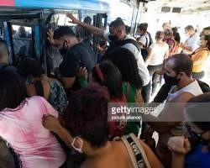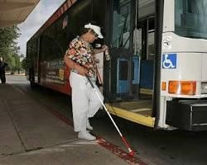

# Method

To make sure the GuidancePro system truly helps people who have trouble navigating public transportation, we talked to a lot of them in different ways. This helped us get a complete picture of the challenges they face every day, which then guided us in figuring out what features the system absolutely needs to have.

## Focus Groups and Interviews:

To understand the needs of people who have trouble seeing when using public transportation, we talked to them directly in a few ways. First, we held group discussions with people. In these safe and friendly settings, they could openly share their experiences commuting, the problems they face, and what features they'd really like in a system to help them. We also interviewed visually impaired students and staff at the university. This allowed us to learn more about the specific challenges they face on campus, which are like the problems they might encounter on other forms of public transportation.

## Case Studies and Academic Research:

In addition to talking directly with visually impaired individuals, we also explored existing research on assistive technologies designed to help people with vision difficulties. This included reviewing academic studies and case studies. By examining this research, we gained valuable knowledge about established methods for creating helpful tools. It also helped us identify areas where current solutions might be lacking. Learning from previous research allowed us to build upon existing knowledge and ensure the GuidancePro system addressed recognized limitations.

## Competitive analysis:

|  |  |  |  |  |  |
| --- | --- | --- | --- | --- | --- |
| **Solution** |  | **Pros** | | **Cons** | |
|  | **Be My Eyes** | * Strong community support with global volunteer assistance. * Simple interface. * Clear video instructions for call reception. * Language selection option. | | * Occasional video delays. * Challenges for blind users in granting microphone access. * Requires internet connection. | |
|  | **Seeing AI** | * Free application, promoting accessibility. * Currency scanner for financial independence. | | * Does not remember user preferences across sessions. * Accuracy issues with nonlinear text. | |
|  | | •  • | Product scanner for informed shopping.  Fast processing times. | •  • | Limited face scanner (cannot determine age). General image scanning has low accuracy (3/10). |
| **TapTapSee** | | •  •  • | Excellent in picture recognition.  Ability to repeat the last identification.  Allows image recognition from camera roll. | •  •  • | Unclear feedback during image recognition.  Lack of technical support. Bad colour scheme |
| **Evelity** | | •  • | Specialized for public transport, catering to a specific user niche.  Provides real-time updates and guidance, enhancing travel experience for users. | •  • | Limited to certain areas and transit networks, reducing its overall reach. May not be fully accessible for all types of disabilities, limiting its user inclusivity. |

## Expert Consultation:

We also consulted with experts in assistive technology, accessibility, and organizations that help people with vision problems. These experts, like those from blindness institutes or haptic technology companies, provided valuable advice. They helped us anticipate design challenges, suggested best practices, and made sure our system aligns with the latest advancements in helping people with visual impairments.

## Online Survey:

To reach a wider audience of people with visual impairments, we also conducted a survey online. We posted the survey on Reddit’s blind forum, and over 12 people participated!This large response shows a strong interest in finding ways to improve how people with limited vision navigate public transportation. The survey asked questions about what features people would find most helpful, the problems they face with current solutions, and their interest in specific functions like object detection and voice guidance.

All these different ways of talking to people with visual impairments helped us collect a lot of information. This information covered what they need and how they feel about using public transportation. We used this information to figure out exactly what features the GuidancePro system should have to solve the biggest problems they face when getting around.

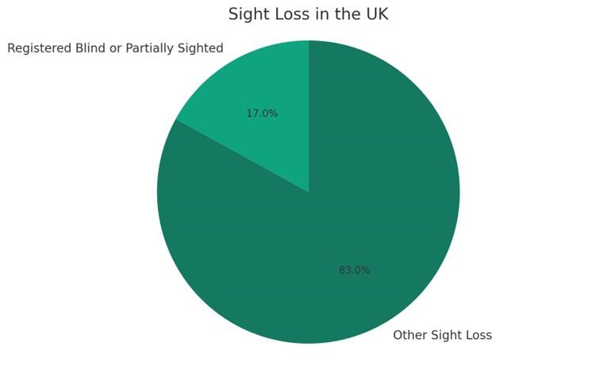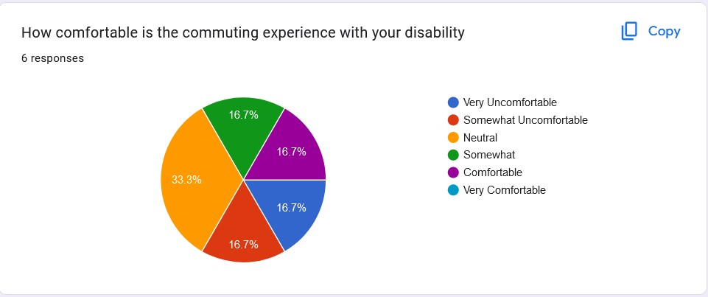

**Figure**

**2**

**:**

**Survey Conducted.**

**Figure 1: % of the blind in the UK.**

# Requirements

All the research we did helped us figure out exactly what features the GuidancePro system should have. Now, let's look at two of the most important things we learned people with vision problems need:

## Real-time Navigation Assistance and Obstacle Detection:

People were frustrated with navigation apps that didn't give them up-to-date information. Group discussions, interviews, and the online survey all showed a strong desire for real-time help, not outdated info. They wanted something that worked in the moment, not just relied on pre-programmed data. In response to this need, the GuidancePro system takes a different approach. It uses real-time information from its companion app to provide voice-guided directions and send touch signals through the walking stick to warn users about obstacles. This ensures a safe and efficient journey by addressing the user need for up-to-date navigation guidance.

## User-Friendly Interface and Accessibility:

Everyone we talked to, whether in group discussions, interviews, or the online survey, agreed on one thing: the app needs to be easy to use! People with vision problems told us they struggled with confusing menus and complicated controls on other navigation apps. The survey backed this up, with many users saying they just want a simple and user-friendly experience. That's why the GuidancePro system is designed with ease of use in mind. Both the mobile app and the way the walking stick gives feedback will be clear and accessible. We'll use easy-to-understand icons, voice instructions, and settings you can adjust to fit your needs.

## Use Cases:

Navigating public transport can be very difficult for anyone with visual impairments so the narration of real-time information when at bus stops and train platforms during navigation will allow users to board the correct bus or train and navigate the public transport network with confidence.

Speaking of navigation brings us to the second use case. Urban environments are rife with potential hazards like uneven pavement, closed roads, and obstacles in the road. The Guidance Pro will be able to alert the user of these obstacles which will allow them to move safely in the inner city.

The stick's utility isn't confined to just cityscapes. Its ability to detect change in terrain and alert the user will enable explore the outdoors independently giving them their autonomy back.

**Figure 3: Use case Diagram.**

# Implementation and Design

Creating the GuidancePro System involved a journey of understanding and improving to meet the needs of visually impaired individuals. Here's how we made it happen:

## Understanding User Needs:

We started by talking to visually impaired people to learn what they need. We did this through group discussions, interviews, and surveys. They told us what they find hard when they're out and about. We listened and noted down important things like needing help to navigate, detecting obstacles, and wanting an easy-to-use device.

## Persona:

**Introducing our persona:** Sarah Thompson aged 28, a visually impaired social worker from an urban city. She seeks a reliable navigation aid that simplifies her commute by providing real-time updates and obstacle detection. Sarah expects the GuidancePro Stick to enhance her mobility and safety. She's all about efficient, stressfree travel, and with GuidancePro, she looks forward to reclaiming her independence and confidence on the move.

**Figure 4: Persona of Sarah.**

## Initial Design Concepts:

After hearing from users, we made rough sketches and low fidelity prototypes of what the app and stick might look like. These were just ideas on paper, not actual products yet. We wanted to see how things could work and how they might look.

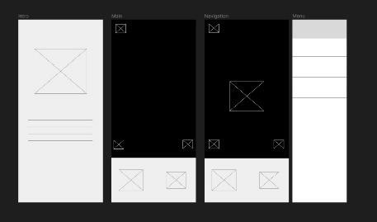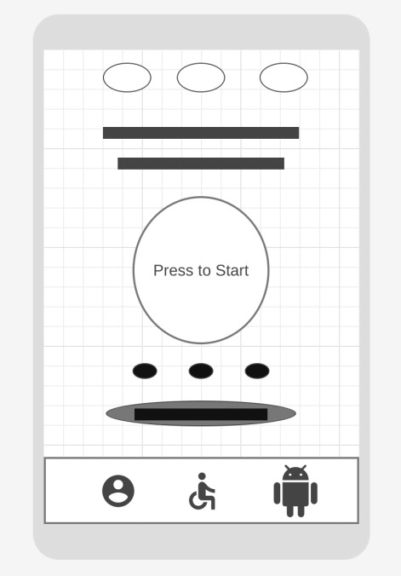

**Figure 5: Low fidelity Wireframe 1. Figure 6: Low Fidelity Wireframe 2.**

## Testing and Feedback:

We showed our designs to users and asked them to try them out. While they did, they talked about what they liked and what was confusing. This helped us see if our ideas were good and if they were easy to understand and use.

**Figure 7: User testing conducted.**

## Balancing Complexity and Simplicity:

Making the app and stick simple to use was hard because we also wanted them to do lots of helpful things. We had to find a good balance between making things easy and making sure they were useful.

## User-Centric Design:

We always thought about what users wanted. We made the app and stick so users could change things to fit what they liked. This way, everyone could make it work just how they wanted.

## Storyboard:

Here is a storyboard or some of the key uses of our product. What you can see in these images are scenarios which will be addressed by our product. Getting around obstacles, being alerted of hazards, and being given navigation information to reach destinations.

**Figure 8: Storyboard.**

## Ongoing Development:

We're still working on making our ideas real. We keep listening to feedback and making changes to our designs. We want to make something that really helps visually impaired people get around easily.

# Prototypes

In our design process, we moved forward by creating different prototypes to see how our ideas would work in practice. We started with low-fidelity wireframes, which were like simple drawings showing the basic layout and features of the app and stick. These helped us get a rough idea of how everything might look and function.

Once we had a clearer picture, we moved on to designing high-fidelity prototypes. These were more detailed and closer to what the final product might look like. They included things like colors, images, and more realistic interactions. We used these prototypes to get feedback from users and see how they felt using the app and stick.

During the evaluation process, we showed the prototypes to visually impaired individuals and asked them to try them out. We wanted to see if they found the designs easy to understand and use. Users were encouraged to provide feedback on what they liked and what could be improved.

By iterating on these prototypes based on user feedback, we were able to refine our designs and make sure they met the needs of our target users. This iterative approach allowed us to continuously improve the usability and functionality of the app and stick, ultimately leading to a better final product.

## Prototype showcase:

**Check the prototype** [**here**](https://www.figma.com/proto/SZdsHAEYN0C7WSHsYxxw6h/Prototype?node-id=112-147&starting-point-node-id=112%3A147&mode=design&t=FrRHWJWd4dSS7Zez-1)

**Backup Link:** [https://www.figma.com/proto/SZdsHAEYN0C7WSHsYxxw6h/Prototype?node-id=112-147&startingpoint-node-id=112%3A147&mode=design&t=FrRHWJWd4dSS7Zez-1](https://www.figma.com/proto/SZdsHAEYN0C7WSHsYxxw6h/Prototype?node-id=112-147&starting-point-node-id=112%3A147&mode=design&t=FrRHWJWd4dSS7Zez-1)

# Evaluation

It's important to see how well the GuidancePro system helps people with vision problems get around. Here's how we're doing so far:

## Meeting Requirements:

Our goal was to make sure our design met the needs we identified from talking to visually impaired individuals. Overall, our design did a good job of including things like helping with navigation, detecting obstacles, and being easy to use. People who tried it out found it helpful and easy to understand, which was great to hear.

## Methods that Worked:

**User Testing:** We asked visually impaired people to try out our design, and their feedback was really helpful. It helped us see what parts were good and what needed improvement.

**Iterative Prototyping:** We kept making prototypes and getting feedback to make things better each time. This way, we could fix any problems early on and make sure the final design was as good as possible.

## Methods that Didn't Work:

While we did a lot of testing, we realized we could have reached out to more people with different types of visual impairments. Next time, we'll make sure to include a wider range of users in our testing.

## Future Iterations:

Next time, we'll test our design with even more people with different types of visual impairments. This will help make sure our design works well for everyone who needs it. We know that design is always changing, so we'll keep listening to feedback and making improvements to make our design even better over time. We see failure as a chance to learn and make things better. If something didn't work in our design, we looked at what went wrong and used that to make improvements. For example, if people found something confusing, we changed it to make it easier to understand.

Overall, our evaluation process helped us see what our design did well and where we could make it even better. By learning from failure and listening to feedback, we're committed to making sure our design meets the needs of visually impaired individuals as best as possible.

# Conclusion

The GuidancePro system was created to help people with vision problems navigate public transportation more confidently and independently. We talked to a lot of people with vision problems to find out what challenges they faced. They told us they needed real-time navigation help, a way to detect obstacles, and information they could easily understand. To address these needs, the GuidancePro system combines a walking stick that gives feedback through touch with a user-friendly mobile app. We designed it to be functional, easy to use, and intuitive for everyone, based on the feedback we received.

## The Future of GuidancePro:

There's still a lot we can do to make the GuidancePro system even better! Here are some ideas for the future:

* The walking stick could learn to tell the difference between different obstacles, like curbs, steps, or uneven ground, and give different types of feedback through touch.
* The app could connect with public transportation systems in real-time to show arrival and departure times, or even make announcements directly on the platform.
* People could adjust the strength of the touch feedback and choose the language for the voice guidance in the app, depending on their preferences.
* We want to have even more people with vision problems try out the system in real-world situations, so we can keep improving it.

By constantly checking how well it works, making changes based on user feedback, and keeping an eye on new ideas, the GuidancePro system has the potential to be a game-changer. It could open a world of independent travel possibilities for people with vision problems.

# References

* National Institute on Disability, Independent Living, and Rehabilitation Research. (n.d.). Assistive Technology.

[online] National Institutes of Health. Available at:

<https://www.nichd.nih.gov/health/topics/rehabtech/conditioninfo>[Accessed 17 Mar. 2024].

* LoPresti, F., Pasta, L., & Russo, T. (2019, September). Public Transport Systems: A Review of Accessibility Issues for People with Visual Impairments. Sustainability, 11(19), 5442. [online] MDPI. Available at:

<https://www.mdpi.com/1424-8220/19/6/1282>[Accessed 15 Mar. 2024].

* Falkenstein, M., Koschinski, M., & Kaup, A. (2020, December). Usability Evaluation of Navigation Apps for People with Visual Impairments: A Systematic Review. Sensors (Switzerland), 20(24), 7320. [online] MDPI.

Available at: <https://www.mdpi.com/1424-8220/22/12/4538>[Accessed 19 Mar. 2024].

* Weller, H., & Thümmel, M. (2007, September). Mobile Navigation Assistance for Blind People. Lecture Notes in Computer Science, 4829, 908-917. [online] Springer Link. Available at:

<https://link.springer.com/chapter/10.1007/978-3-030-68133-3_6>[Accessed 21 Mar. 2024].

* American Foundation for the Blind. (n.d.). Orientation and Mobility Services. [online] American Foundation for the Blind. Available at: <https://www.aerbvi.org/division_o-m>[Accessed 18 Mar. 2024].
* National Center for Transit Research. (n.d.). Public Transportation Accessibility. [online] University of South Florida. Available at: <https://www.cutr.usf.edu/healthcarechicago/>[Accessed 20 Mar. 2024].
* NICE (National Institute for Health and Care Excellence). (2006). Social Care Institute for Excellence. Social care and community equipment for people with visual impairment. [online] RNIB. Available at: <https://www.rnib.org.uk/professionals/health-social-care-education-professionals/social-care-professionals/>[Accessed 16 Mar. 2024].
* Government of the United Kingdom. (2023). Disability, Accessibility and Blue Badge Statistics: England 2022 to 2023. [online] GOV.UK. Available at: [https://www.gov.uk/government/statistics/disabilityaccessibility-and-blue-badge-statistics-2022-to-2023](https://www.gov.uk/government/statistics/disability-accessibility-and-blue-badge-statistics-2022-to-2023) [Accessed 20 Mar. 2024].

**Appendi**

**ces**

**:**

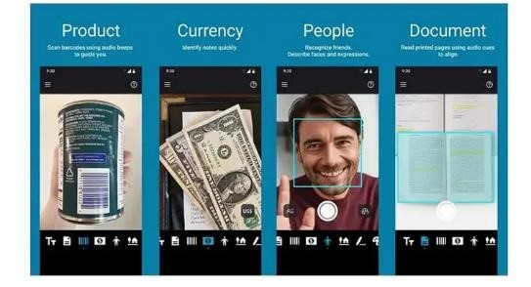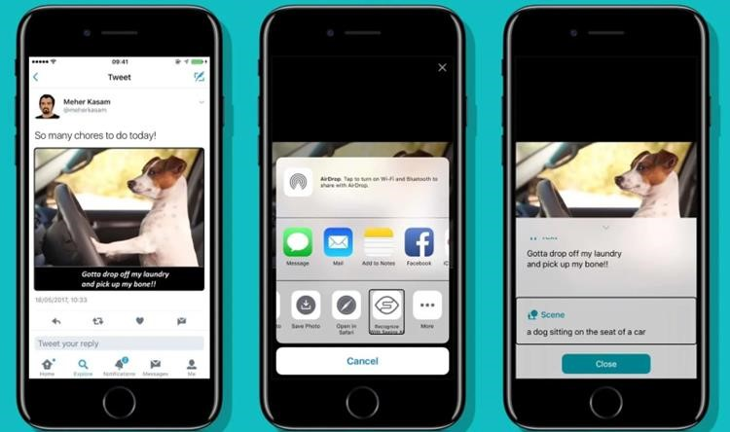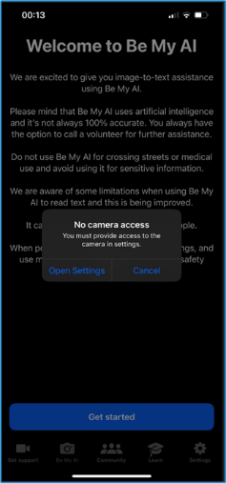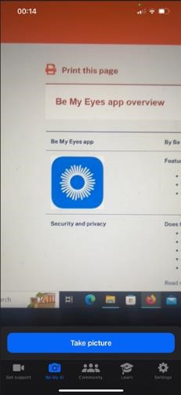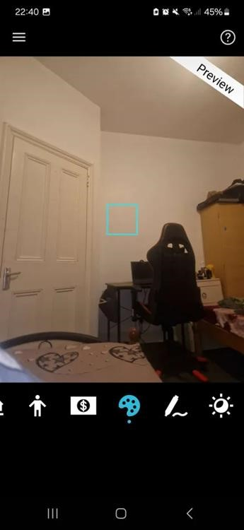

**Figure 9: Chart 7: Number of trips per person by disability status and income quintile: England, 2022 – DIS0409**

**Figure 10: Chart 7: Number of trips per person by disability status and income quintile: England, 2022 – DIS0409**

**Figure 11: Survey analysis.**

**THE END**